Space Relations – Part 1

Student’s Name
Submission Date

Relative Position Vectors

Part A: Relative Positions in 1-D
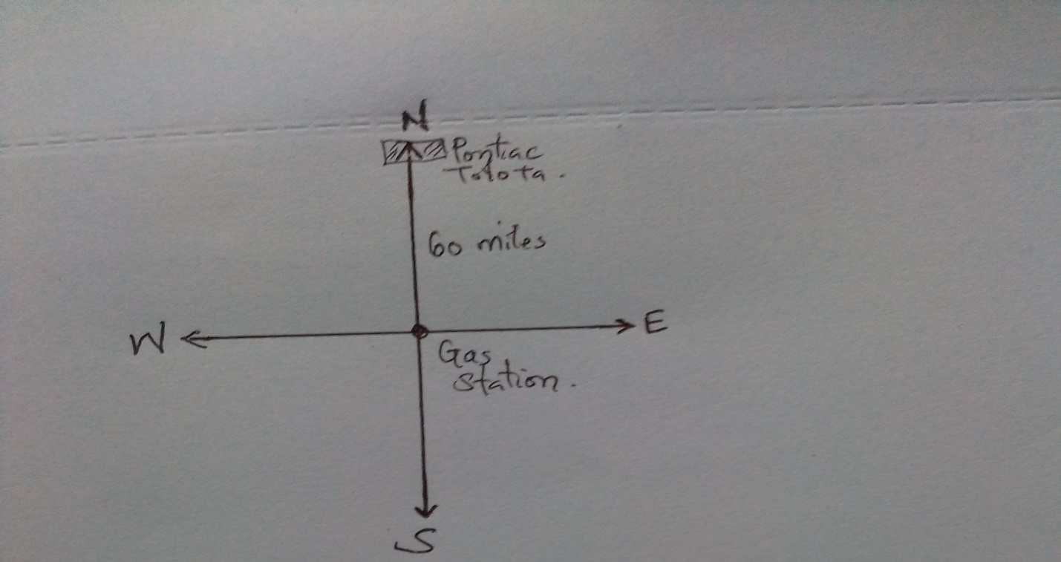
- The Pontiac and the Toyota are both parked due North of the gas station. Thus, the Pontiac is 0 miles away from the Toyota.

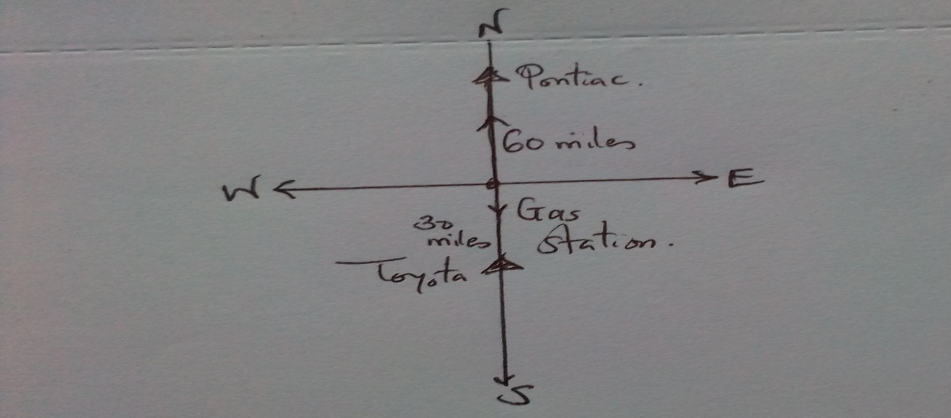
- The Pontiac is 90 miles due North from the Toyota.
- a) The Toyota is 30 miles due south from the Pontiac.
b) The gas station is 60 miles due North from the Toyota.
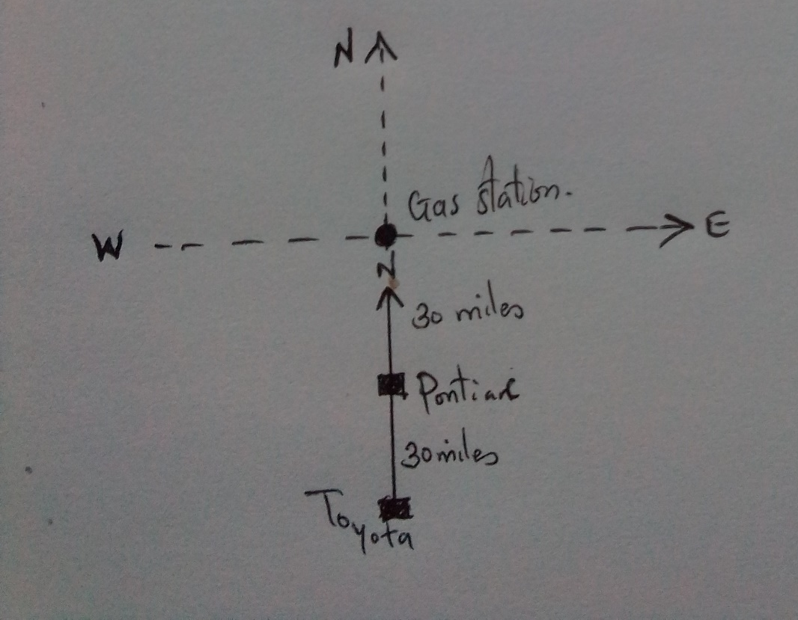
c) The Bird’s-eye-view diagram

d) The Pontiac is 30 miles due south from the gas station. To reach at the Pontiac, you would walk for 30 miles in the south direction from the gas station.

Part B: Relative Positions in 2-D
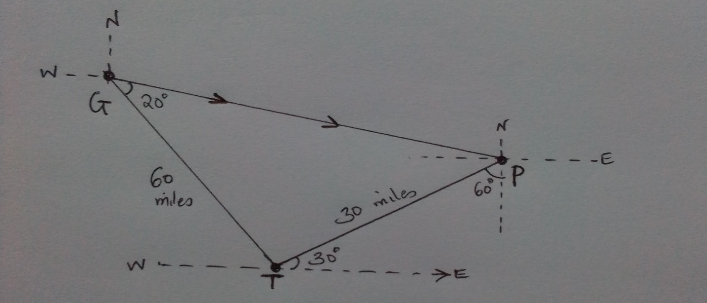
- The Bird’s-eye-diagram
- The Toyota is 30 miles south west from the Pontiac.
- The gas station is 60 miles, 20 degrees North West from the Toyota.
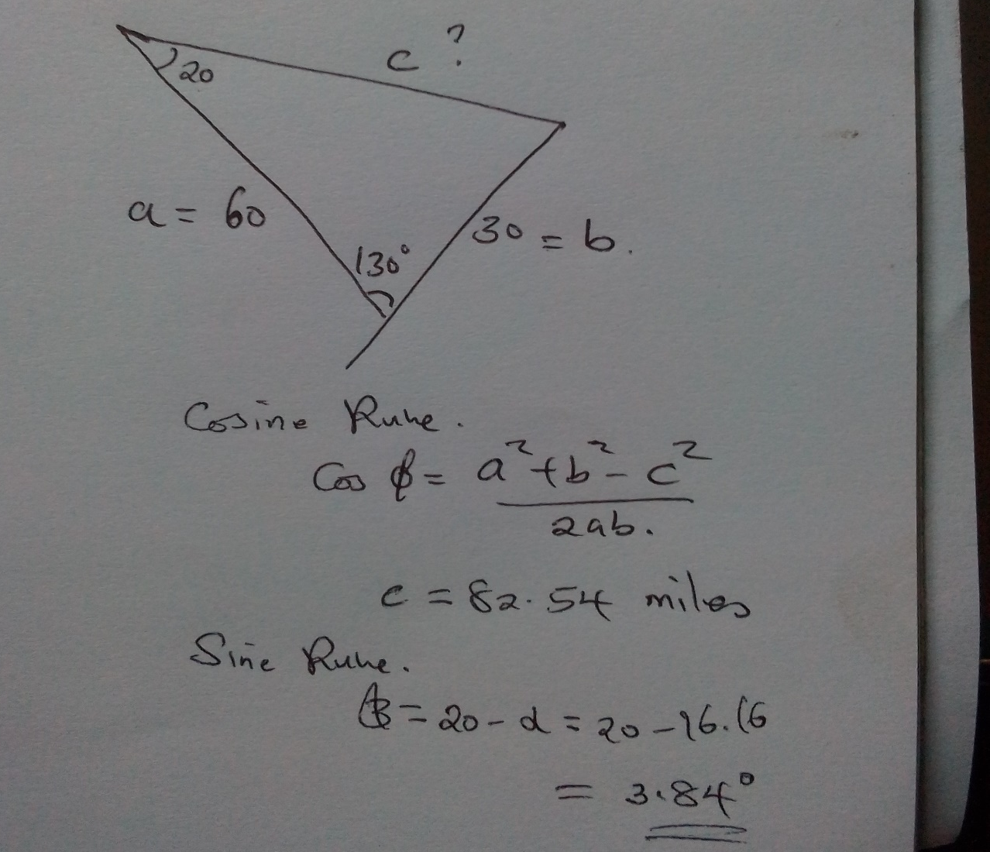
- The arrow is drawn in the diagram above.
- The Pontiac is 82.54 miles away from the gas station, 3.84 degrees south east.

Relative Velocity Vectors
- Yes. The direction can be determined by the angle the rowboat makes while the needle is pointing the north. The velocity cannot, however, be known.
- The velocity of the speedboat is 40 mph in the west direction because we see it going towards the west.
- Relative to the speedboat, the rowboat is moving at 40 mph in the east direction
- The torpedo moves northwards while we are in the rowboat and the speedboat moves in the west direction. The torpedo is moving in the northwest direction relative to the rowboat.
- The velocity of the speedboat is the same as that of the torpedo that is 40 mph. using the vertical and horizontal components, and angle of 45 degrees is obtained. The direction of motion is relative to north, due west i.e. northwest.

